

News Aggregator

Sistemas Multi-Agente

2018/2019

Małgorzata Salawa nº52214

Nuno Rodrigues nº52214

Index

Description 2

Project Structure 2

Agents developed 2

Aggregator Agent: 2

Finder Agents: 3

Presenter Agent: 3

Code Structure 3

Results and Conclusion 4

Bibliography 4

# Description

For this project we developed a news presenting agency, composed by a Presenter Agent, a News Aggregator Agent and multiple Finder Agents.

The agency works with a FIPA-ContractNet model, in which the Aggregator runs as the Contractor and the Finder agents as Participants. This model will be more elaborated further on in the Agent Description section.

All news articles presented come from multiple RSS feeds, some presented in XML, some not, thus we employed multiple web scraping and parser libraries such as JSOUP and ROME.

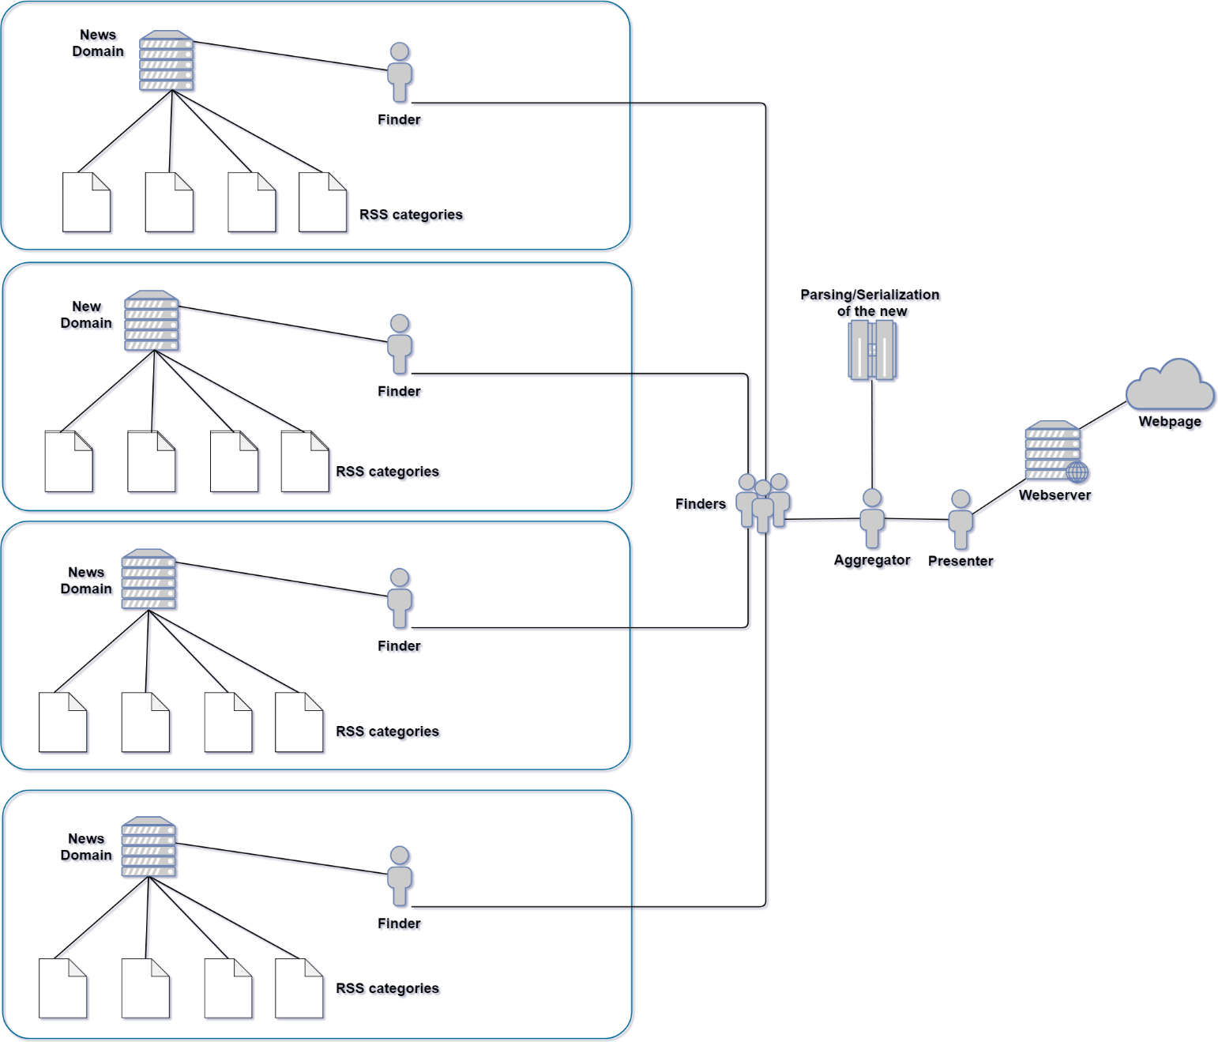We also went a step further and made it so queries can be asked at any time to the Aggregator, and the results are presented in real time in a deployed web server.

Figure 1: Model design

# Project Structure

## Agents developed

Aggregator Agent:

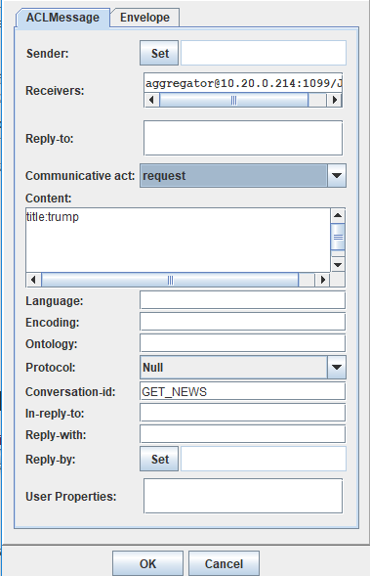This agent acts as the contractor in the contract net. It receives queries by having a FIPA-ACL message sent to him with Communicative Act being **request**, Conversation ID being **GET_NEWS**, and Content being **title:xxxx**, directing those queries to the finder agents.

Figure 2: Example Message

These will reply to the request with a Boolean meaning that it can either search for the giver query or not, and it accepts all positive responses.

We opted by a model were the proposal sent by the Participants propose not a cost or time for the operation, but whether they are able or not to search for the given query, since the Aggregator may accept multiple proposals.

After the Participants inform the Aggregator of the results, it sends the results to the Presenter Agent via FIPA-ACL messages.

This agent ends up being a Hybrid agent, with a BDI model. Its desire being to gather the news, with the belief that the Finder agents can do that, and with the intention of setting contracts with these agents in order to do so.

### Finder Agents:

The Finder Agents are bound to a specific domain (news source), and they act as Participants in the FIPA-ContractNet. They are assigned a category at creation (eg. Politics or Sports), and if they are invalid, a “random” category is assigned to them. The categories assigned must be present in the news outlet domain, being invalid meaning, they are not, and “random” assignment meaning they get a random category form the ones listed in the page. They know the categories by web scrapping the page with JSOUP.

In the Evaluate Request step agents do the steps above described regarding the categories.

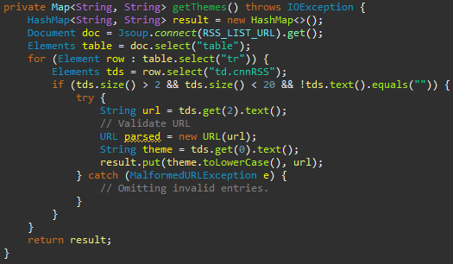

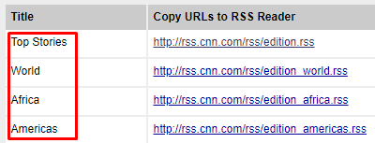

Figure 3: Categories in the web page

Figure 4: Category web scrapping example

In the Perform Request step, agents check whether the request was for a category/theme, title or description, scrapping and parsing the RSS feeds looking for they desired keyword, received as the request from the Aggregator, in these fields. When found, the news are encapsulated in a data type we developed and sent to the Aggregator for parsing.

For sources, we opted to use CNN and Sky News as our more general ones, and FOX Sports for a more specific one.

### Presenter Agent:

The Presenter Agent receives the parsed news as a FIPA ACL Message from the Aggregator, transforms them into JSON files and puts them on the webserver.

The web server is running in localhost.

## Code Structure

# Running model and Agent states

# Results and Conclusion

# Bibliography